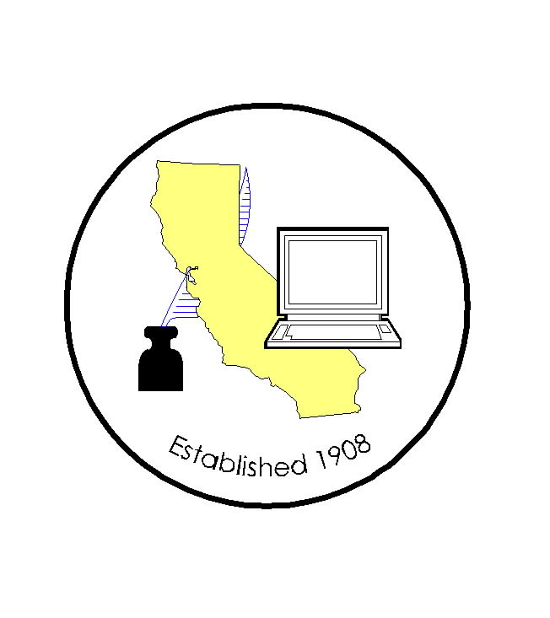
CALIFORNIA ASSOCIATION OF

CLERKS AND ELECTION OFFICIALS

DATE: March 10, 2008
TO: CACEO Members, Legislative Committee
FROM: *Neal Kelley, Orange County Registrar of Voters
SUBJECT: CACEO LEGISLATIVE COMMITTEE MEETING

DATE: Friday, April 4, 2008

TIME: 9:00 a.m. – 3:00 p.m.

LOCATION: Ramada University Phone: (559) 224-4040
324 East Shaw Avenue (800) 241-0756
Fresno, CA 93710 Rate: $84 sgl/dbl
Deadline for group rate: March 20, 2008
SUBCOMMITTEES: Thursday, April 3, 2008
(contact Subcommittee Chairs for additional information)

REGISTRATION
Registration deadline: March 27, 2008
No refunds will be provided after this date

Name: ____________________________________________________

County/City: ____________________________________________________

Fee enclosed: Member: $55.00 (payment received by March 27th)
Auditor cutting check
$105.00 (payment received after March 27th)
Paid for year

Non-Member: $105.00 (payment received by March 27th)
$155.00 (payment received after March 27th)

Check payable to: California Association of Clerks and Election Officials

*Return to: Neal Kelley, Orange County Registrar of Voters
P. O. Box 11298
Santa Ana, CA 92711-1298
phone: (714) 567-7620
fax: (714) 567-7627
e-mail: linda.strickland@rov.ocgov.com

